

ELEX 2120: Electronic Circuits I

LAB #7 – Robot Project

|  |  |  |
| --- | --- | --- |
| Student Name: Faniel Yemane | Student Number: A01182890 | Set: C |
| Student Name: Ethan Bosiak | Student Number: A01314624 | Bench#: 15 |

# Introduction

The objectives of the lab are to apply the electronic circuits built in previous labs to design and built a robot car with a single +5V supply that contains the following components:

* DC motor drivers with bidirectional control
* LED indicators for various movements
* Speaker and sound effects that work in conjunction with the robot movements

We were also challenged as a bonus to design various enhancements to the car of our choosing.

# DC Motor Driver

We designed the DC motor driver control using a single L293D H-Bridge IC. The direction control is implemented using three switches using the 4xSPDT Grayhill switch.

For our project, we used Tinkercad to design and troubleshoot the circuit before it was physically wired. The right side of the schematic corresponds to the front of the car, and the top corresponds to the left side of the car.

As Tinkercad does not have all the components included in our parts kits, we swapped some components for the schematics. Tinkercad does not have a 4xSPDT Grayhill Switch in its components list, we used three slider switches as our SPDT switches. We also used regular DC motors instead of the servomotors. This did not affect the circuit logic.

For the physical circuit’s Grayhill switch, we used Switch 1 to control pins 14 (active high) and 1 (active low) to power the motor driver, which causes the car to stop and go. We used Switch 3 to control pins 10 and 5 for the direction of the left wheel motor. We used Switch 4 to control pins 8 and 7 for the direction of the right wheel motor.

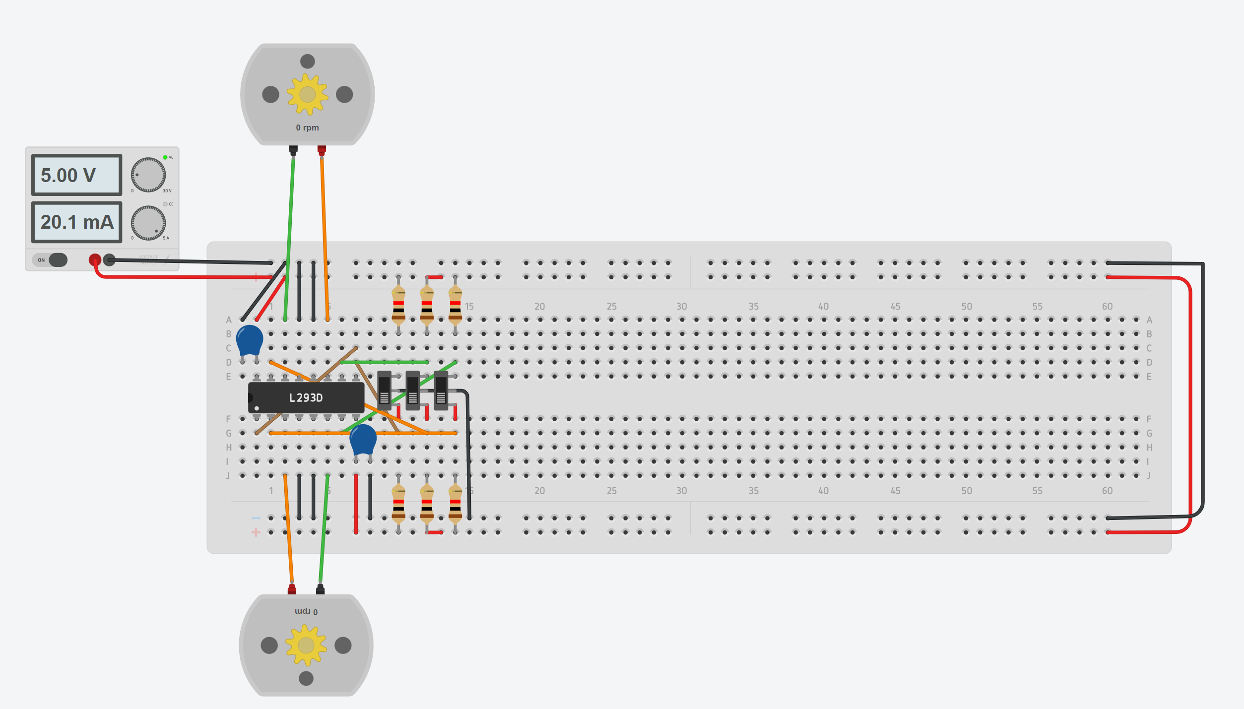

*Figure 1 – Motor driver circuit using slider switches from Tinkercad*

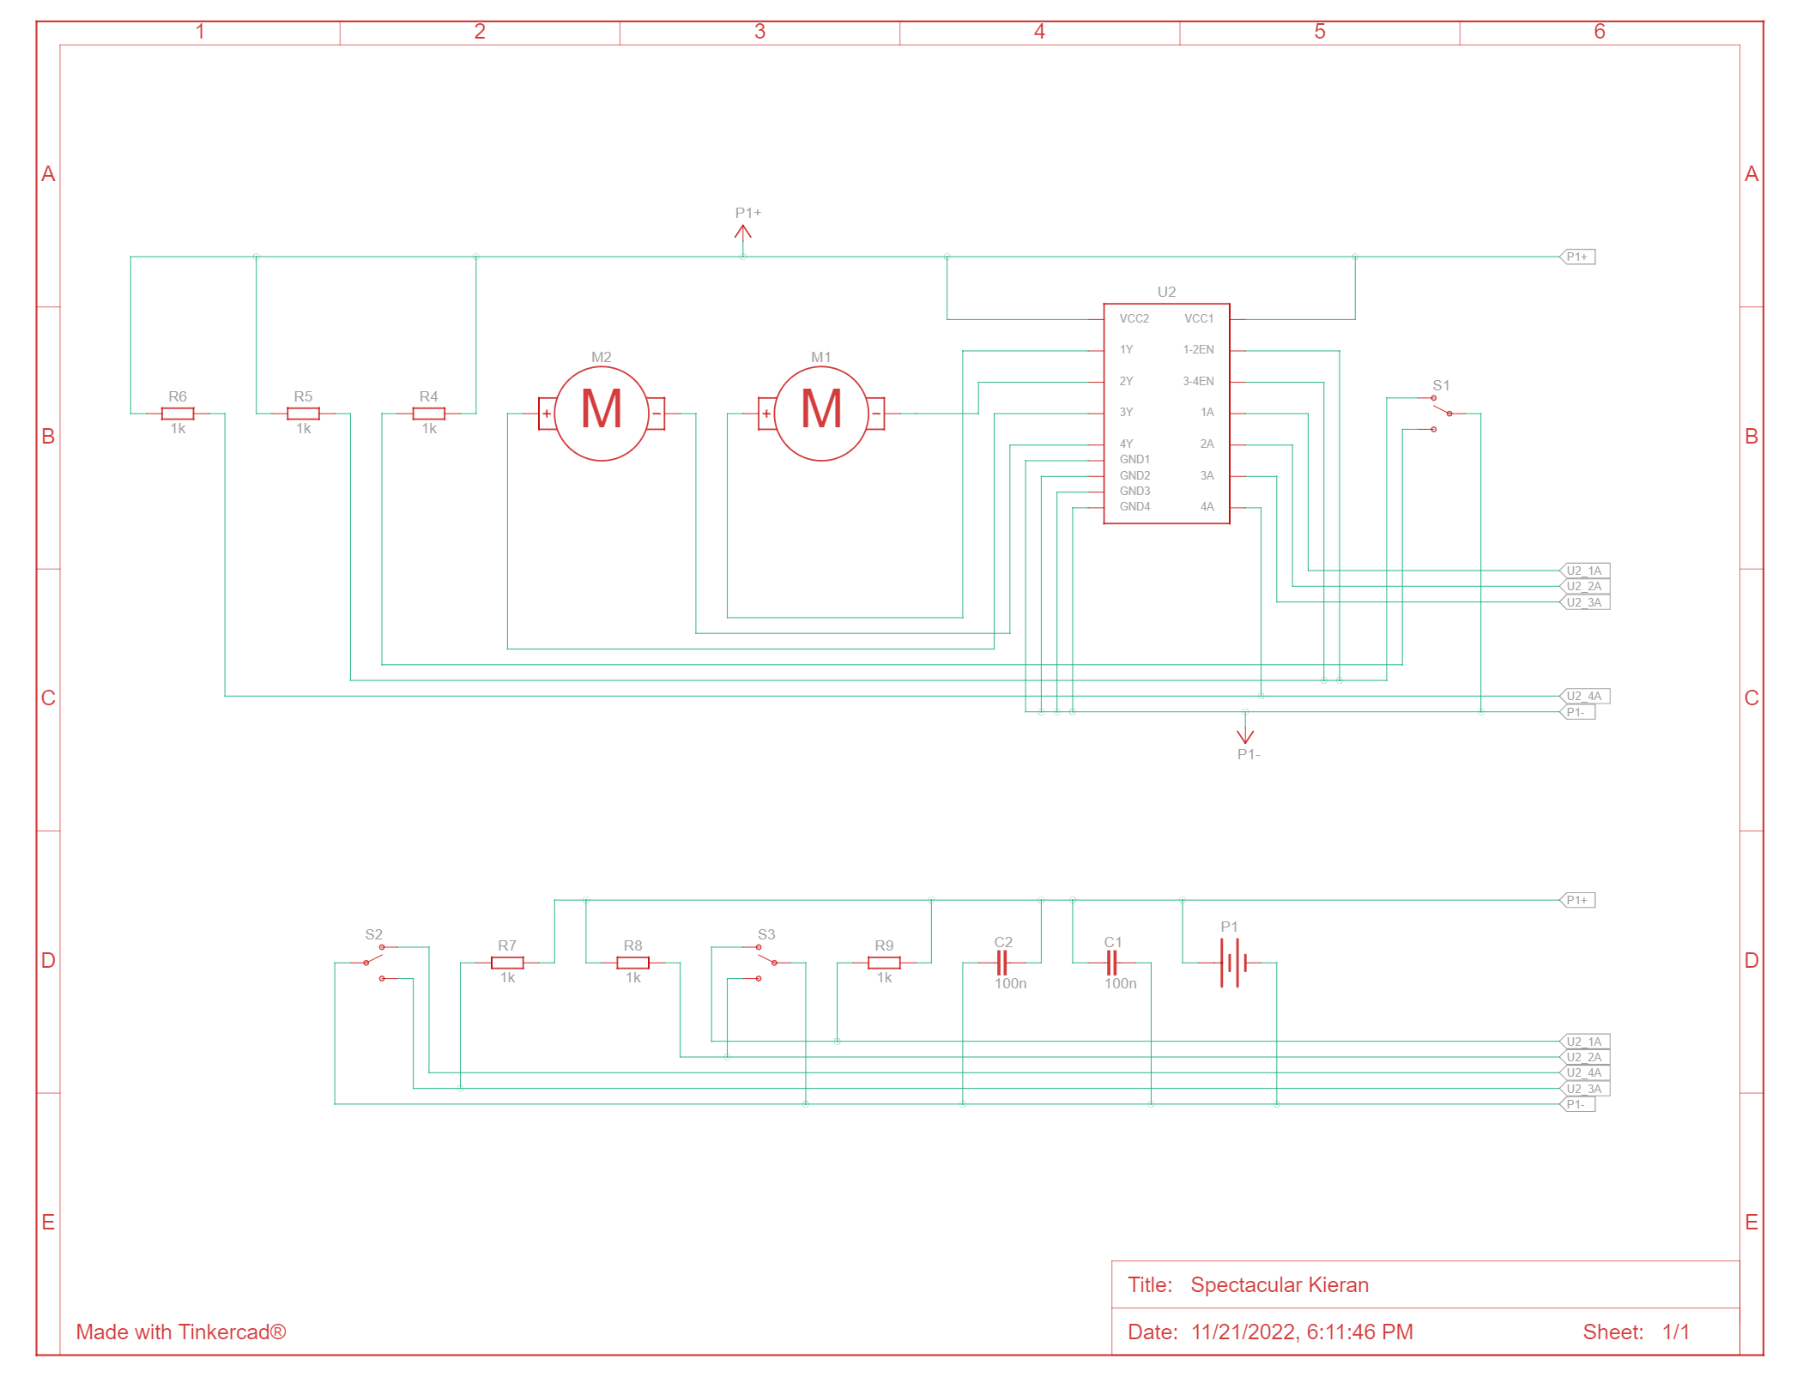

*Figure 2 – Motor driver schematic*

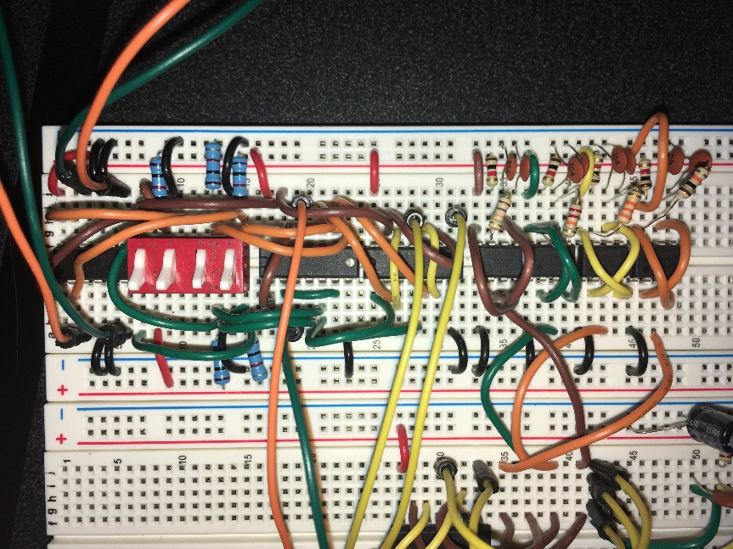

*Figure 3 – We used Switches 1, 3, and 4 on the Grayhill switch.*

In the circuit’s initial state, the switch positions are all down and turned off. While Switch 1 is on, the L293D H-Bridge IC will be powered on, turning the motors. If Switch 1 is off, the H-Bridge IC will turn off, causing the car to **stop**.

While Switch 1 is on, the direction of car is controlled by the other switches as follows:

* If Switches 3 and 4 are both off, both wheels rotate backwards, causing the car to **go backwards**.
* If Switches 3 and 4 are both on, both wheels rotate forwards, causing the car to **go forwards**.
* If Switch 3 is on and Switch 4 is off, the left wheel rotates forwards, while the right wheel rotates backwards, causing the car to **turn right**.
* If Switch 3 is off and Switch 4 is on, the left wheel rotates backwards while the right wheel rotates forwards, causing the care to **turn left**.

# LED Lighting Unit

We used four LEDs to indicate the direction of the car. The green LED indicates moving forward, the red LED indicates turning to the left, the blue LED indicates turning to the right, and the yellow LED indicates moving backward. The LEDs turn on depending on the state of the switches with two 74HC08 ICs which implement AND gates.

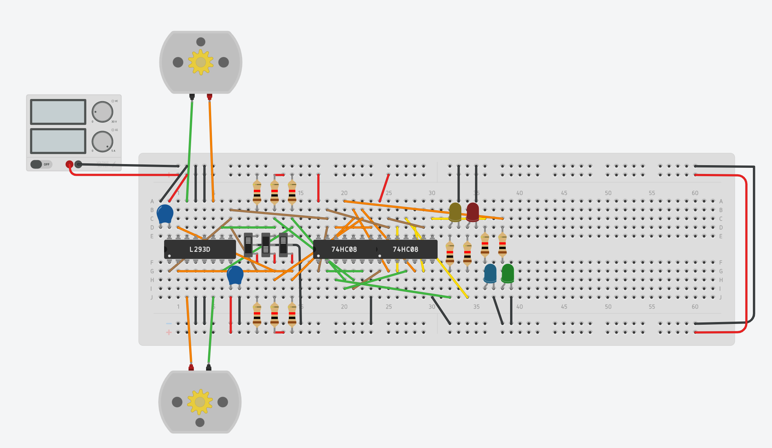

*Figure 4 – LED Lighting Unit circuit*

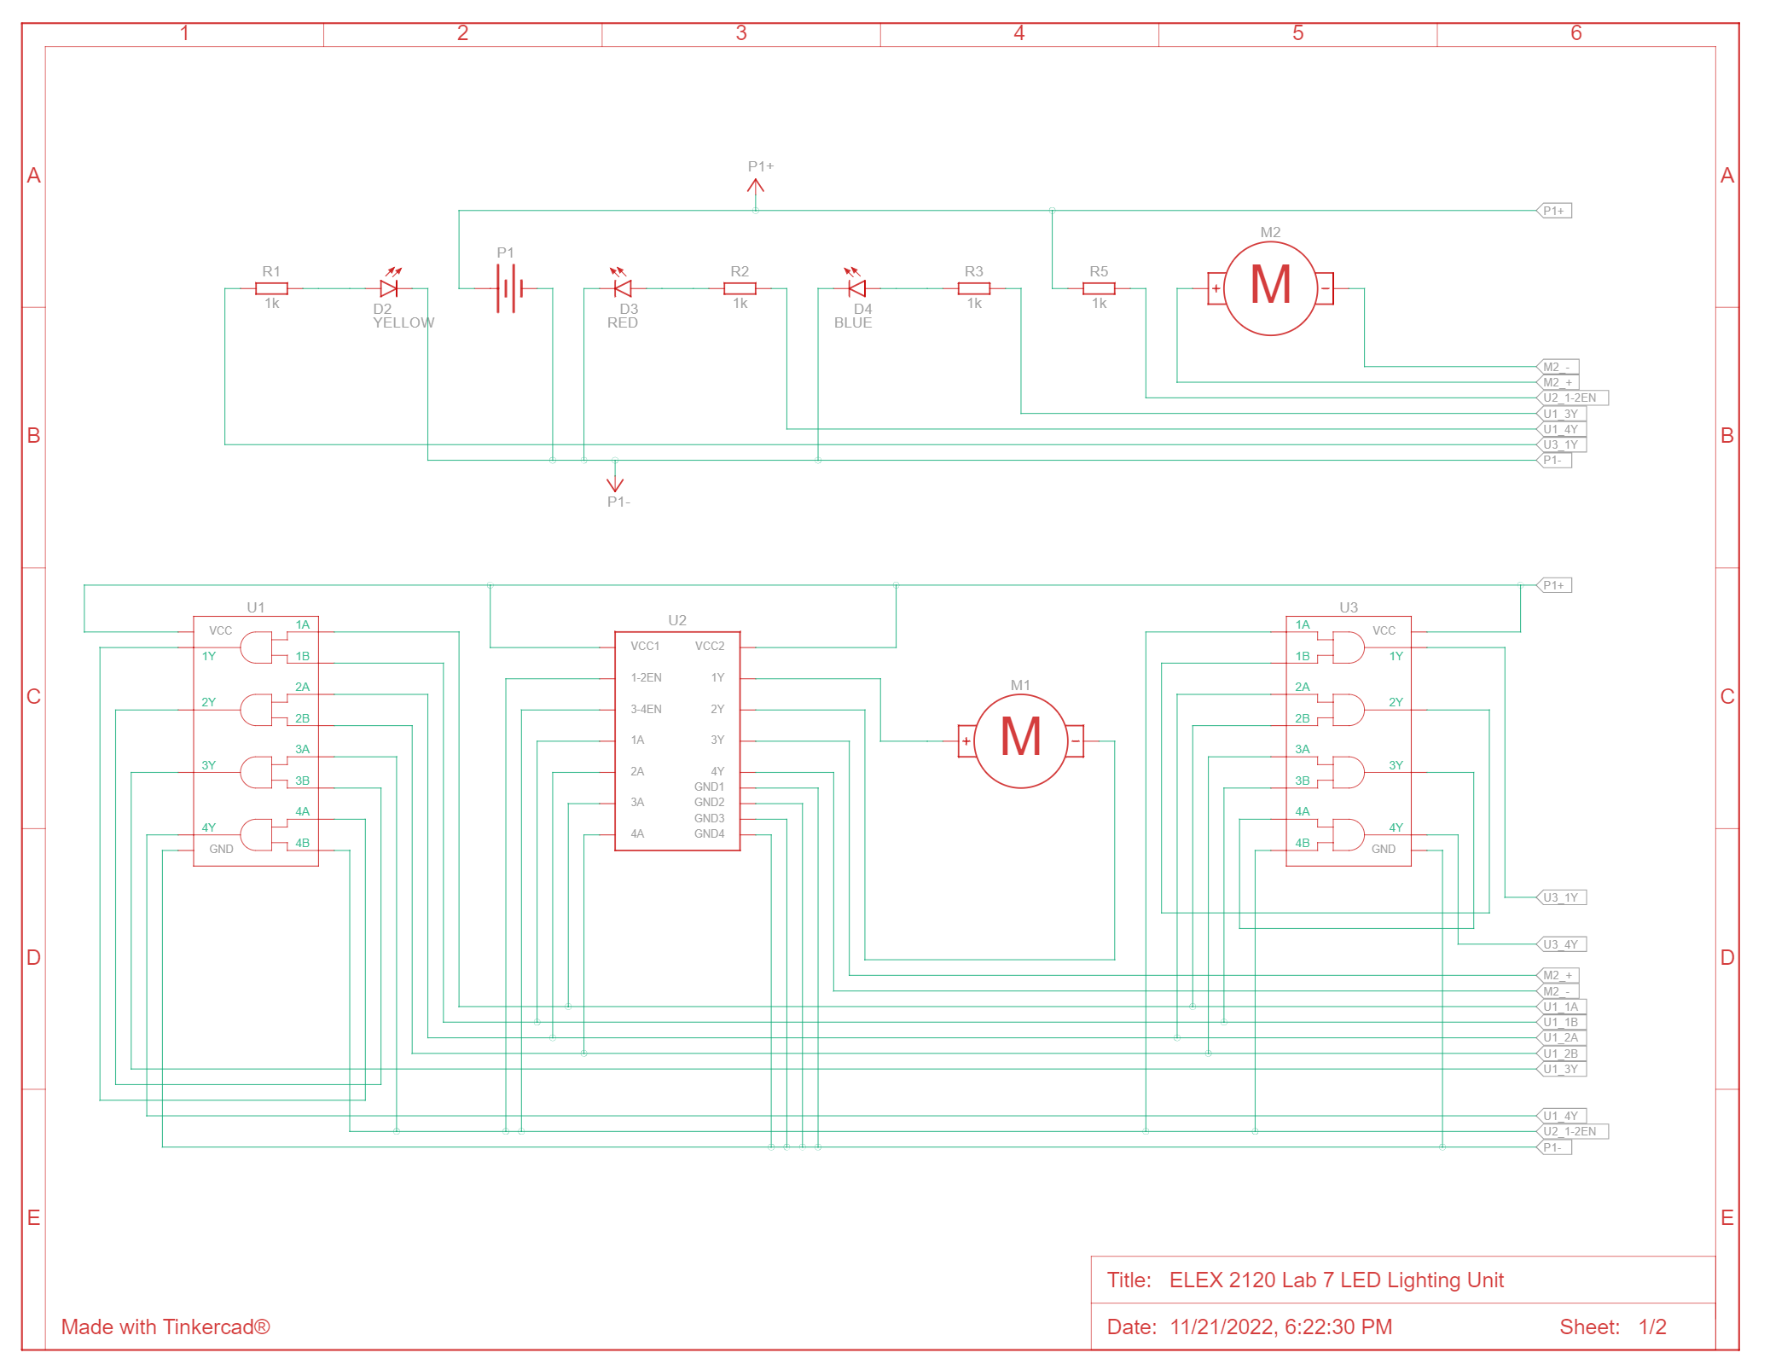

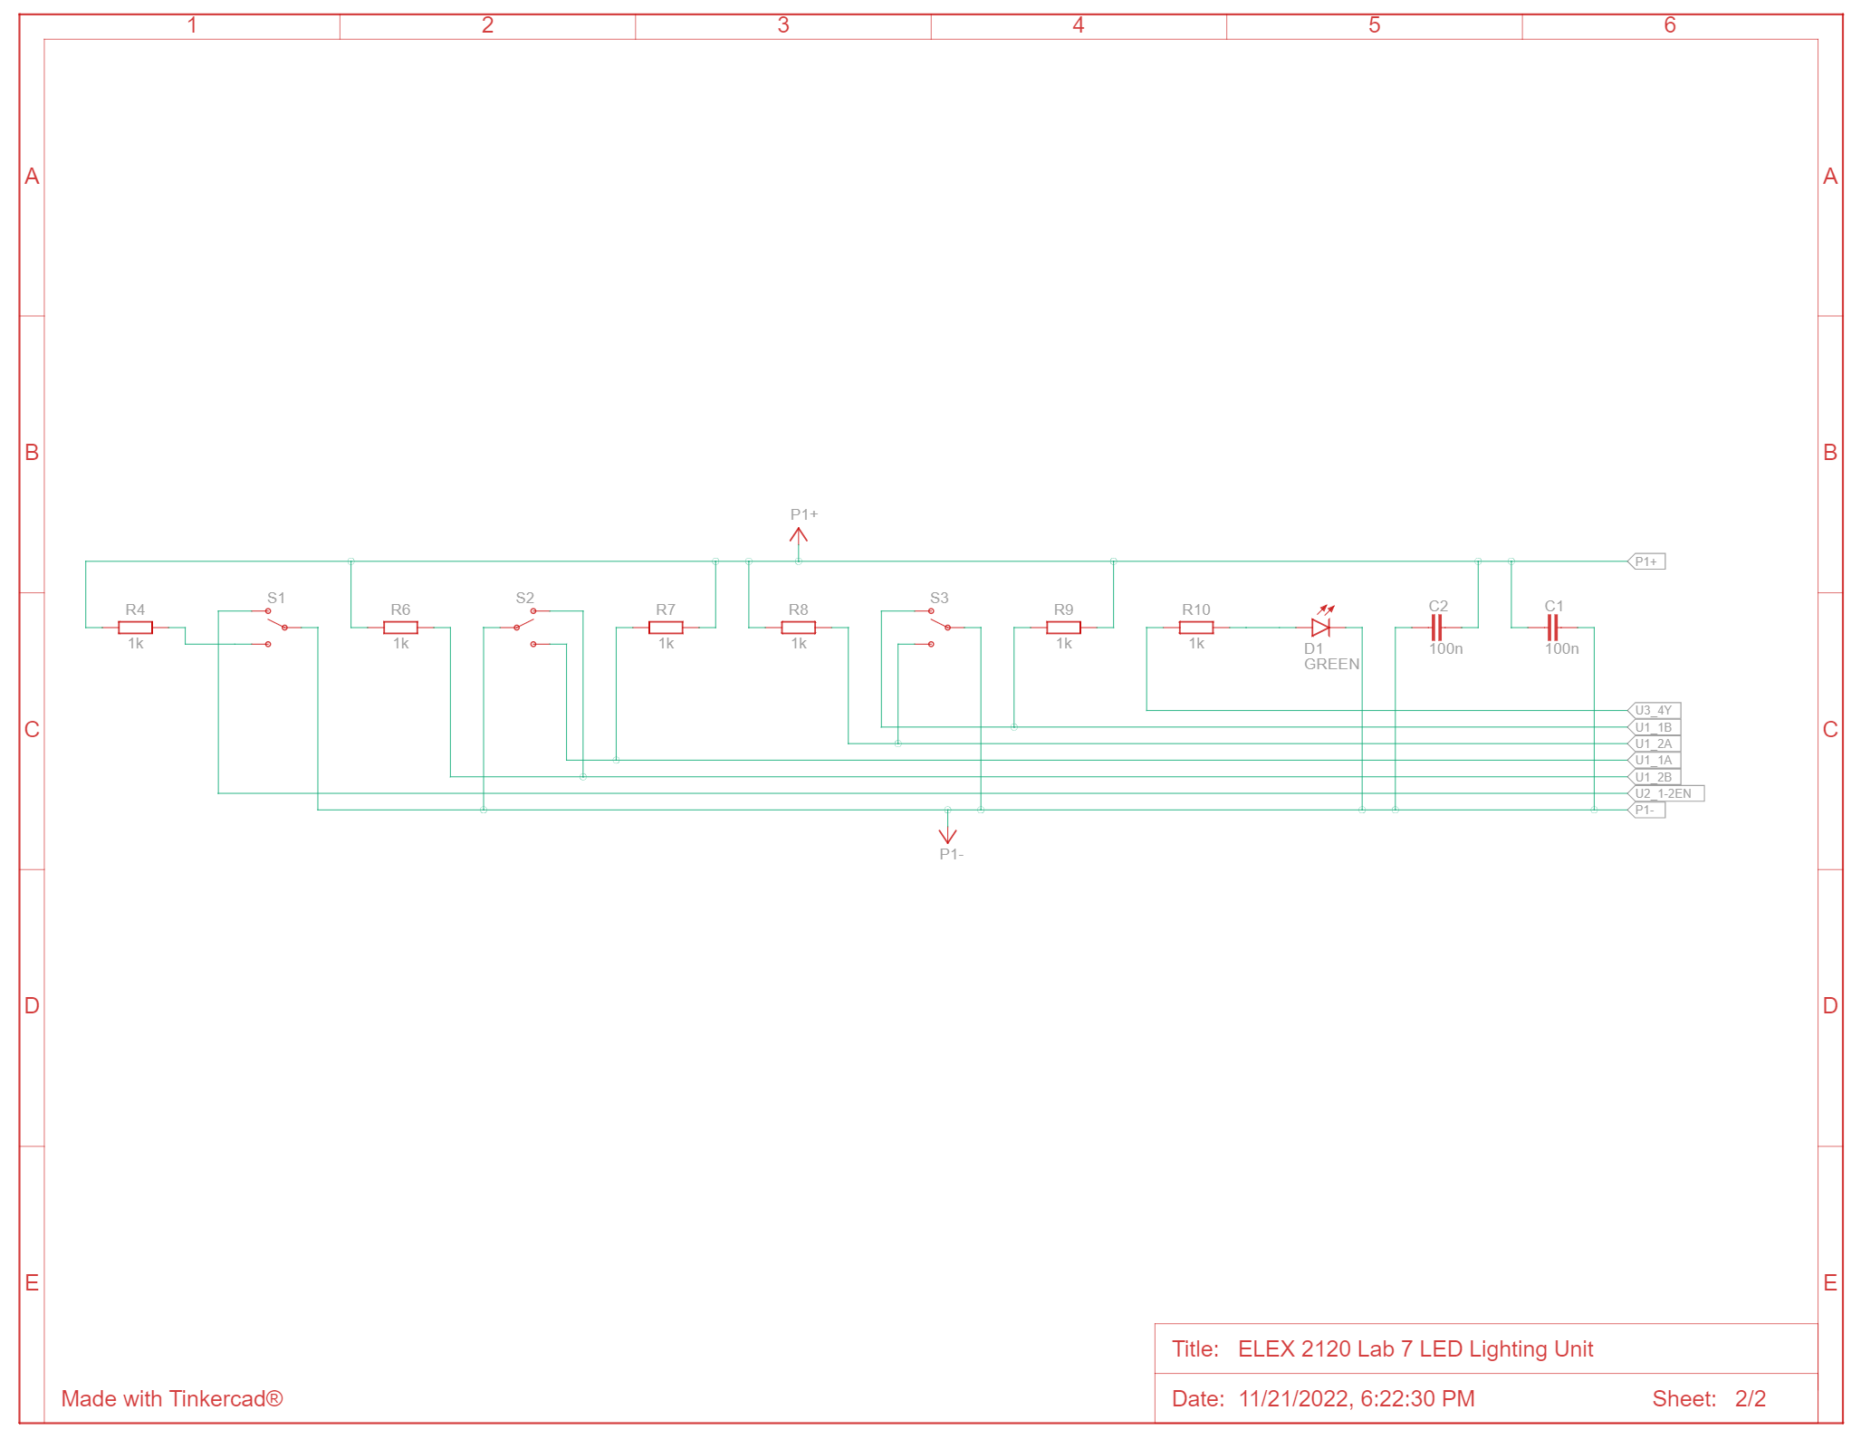

*Figures 5-6– LED Lighting Unit schematics*

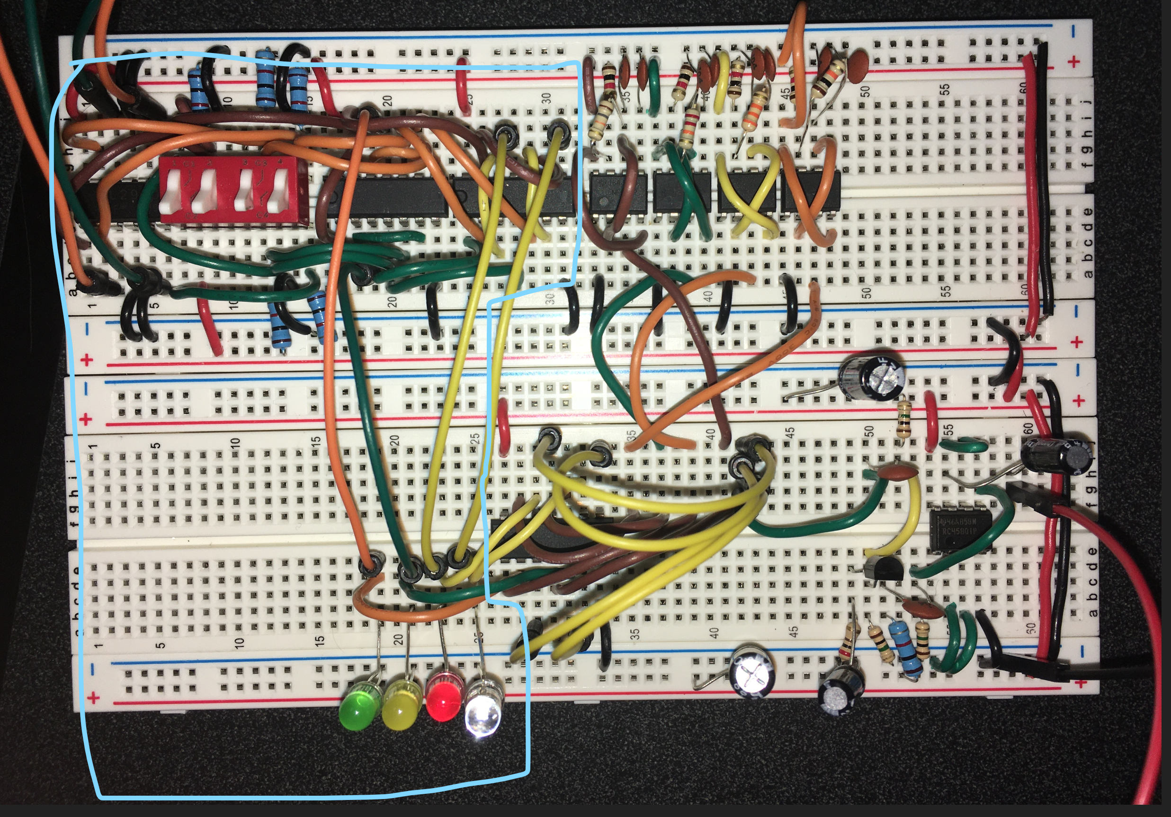

*Figure 7 – Picture of LED lighting unit.*

The LEDs turn on as follows:

* The green LED turns on if Switch 1 is on, 3 is on, and 4 is on. This is when the motors are on and both wheels are turning forward, moving the car **forwards**.
* The yellow LED turns on if Switch 1 is on, 3 is off, and 4 is off. This is when the motors are on and both wheels are turning backwards, moving the car **backwards**.
* The blue LED turns on if Switch 1 is on, 3 is on, and 4 is off. This is when the motors are on, the left wheel is turning forward, and the right wheel is turning backward, turning the car **right**.
* The red LED turns on if Switch 1 is on, 3 is off, and 4 is on. This is when the motors are on, the left wheel is turning backwards, and the right wheel is turning forwards, turning the car **left**.
* None of the LEDs are on if Switch 1 is off. This is when the H-Bridge IC is not powered.

# Sound Effects Generator

We used the standard 555 timer ICs to generate our sound effects. The 555 timer IC is a chip that can be used for timer and pulse generation applications. We used these timers to create four unique sound effects depending on the car’s movement.

We used four 555 timers using different resistors for each to produce four pulses at unique frequencies. On the Tinkercad circuit view, the 555 timers from left to right produce pulses of frequencies 390 Hz, 320 Hz, 215 Hz, and 687 Hz respectively at a 50% duty cycle. All the 555 timers are on and outputting these frequencies.

We then used another 74HC08 IC to connect the pulses from each of the 555 timers to the signals to the LEDs. Since we connected each LED signal and 555 timer pulse with an AND gate, this would produce a signal that would turn on at a specific frequency when the corresponding LED is turned on.

After the bottom 74HC08 chip, the four pulses get shorted into the amplifier circuit on the bottom right of the schematic, which connects to the speaker. This means that when the car moves one way, only one LED will turn on and its corresponding pulse will be sent to the amplifier circuit. The four LEDs are in parallel with the signals sent to the amplifier circuit and drop the voltage from 5V to 0.5V.

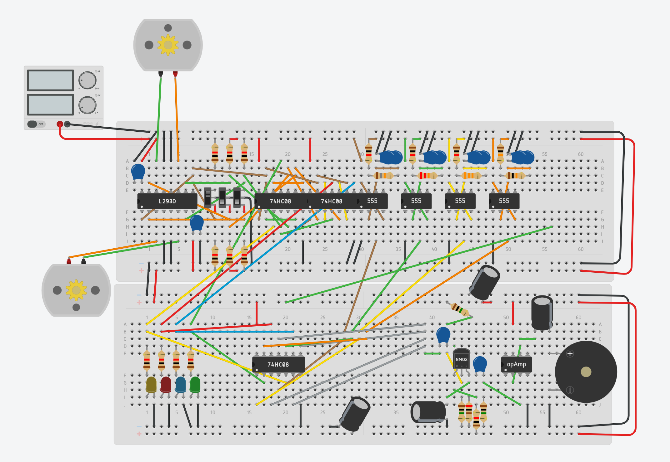

*Figure 8 – Sound effects generator circuit. The bottom right is the sound amplifier using a 741 chip instead of the RC4580 chip.*

The amplifier circuit was built using a common source amplifier with an n-MOSFET under voltage divider biasing with bypass capacitors like Lab 6. The amplifier circuit has a negative voltage gain of -4 and outputs a voltage signal of -2V.

In our physical circuit, this signal was sent to a RC4580 buffer chip which will then output the signal to the 8 Ω speaker. The RC458 chip is a dual op amp for audio applications and outputs a high current for the speaker. During troubleshooting, we neglected to add a voltage divider between the amplifier and the buffer which would have increased the sound coming from the buffer.

In Tinkercad, the RC4580 buffer chip is not available in the components list and we therefore had to use the LM741 op amp chip in the schematic.

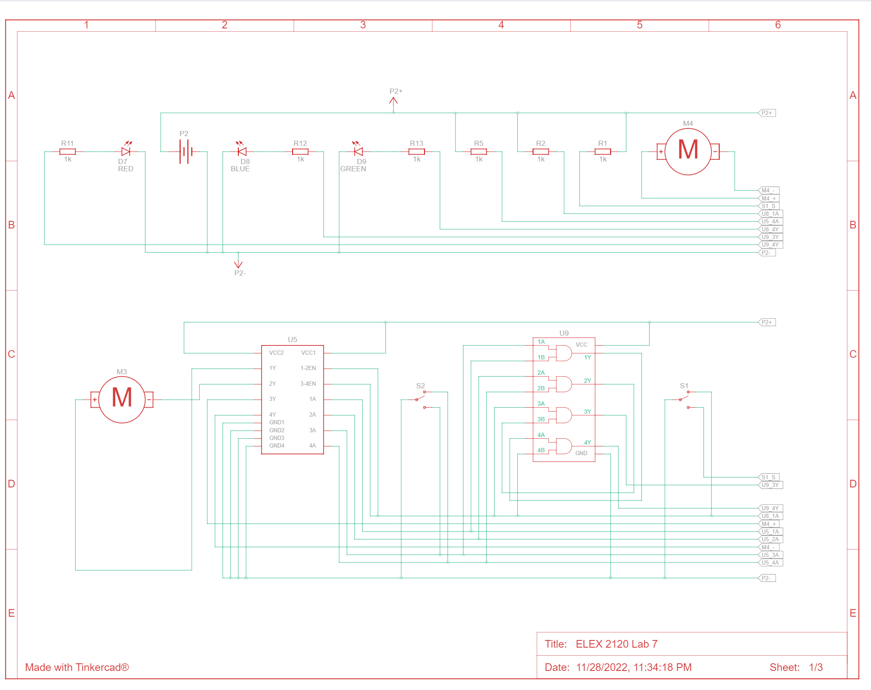

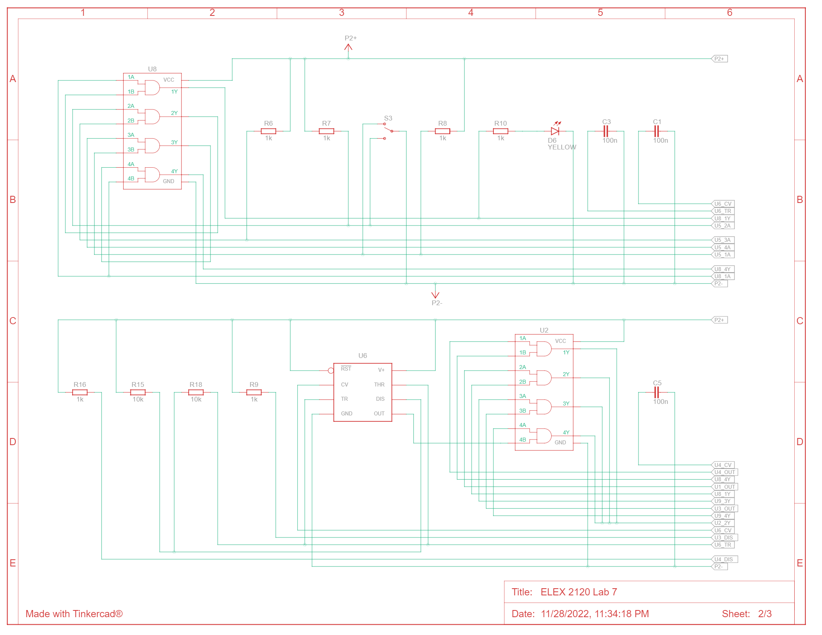

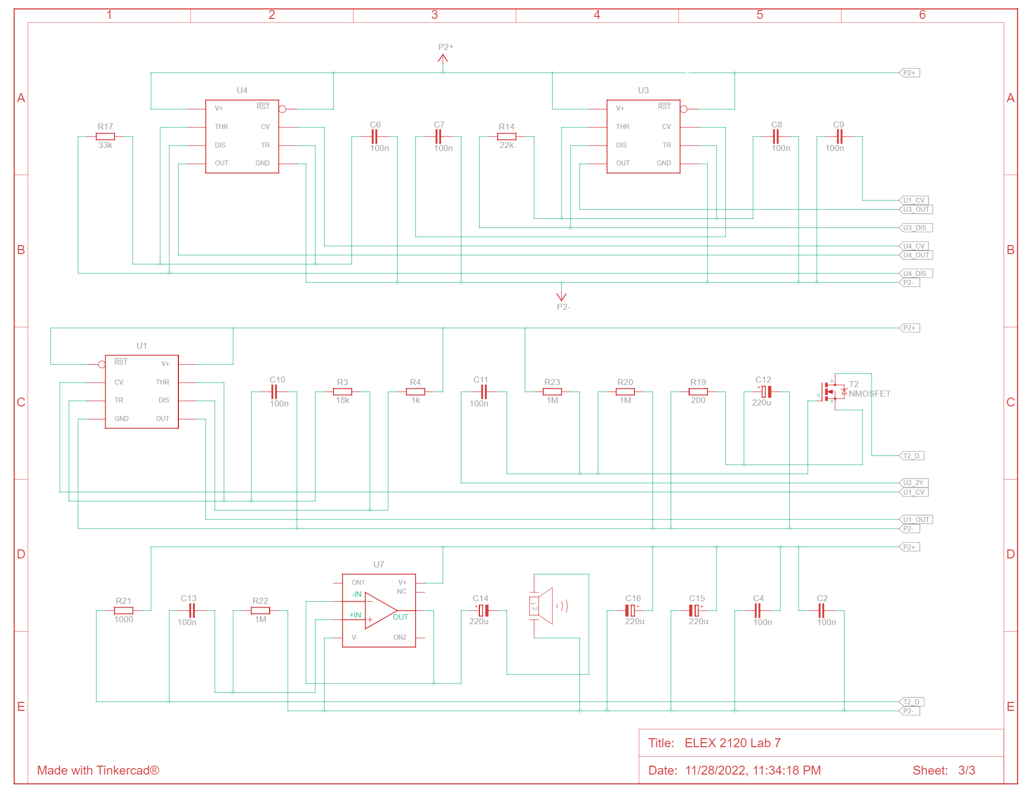

*Figures 9-11 – Sound effects generator schematics*

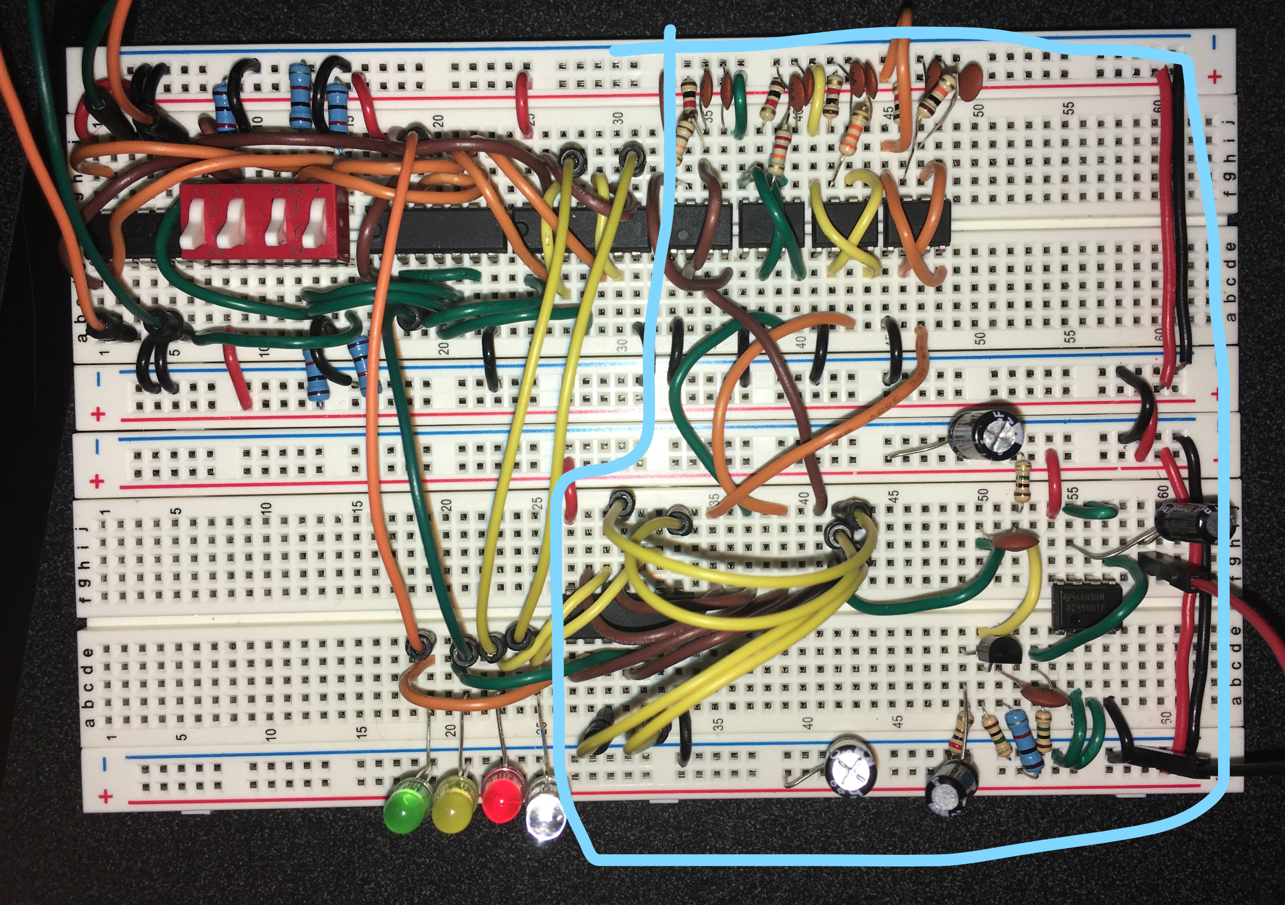

*Figure 12 – Picture of sound effects circuit. We used the RC4580 buffer chip on the bottom right.*

# 

# Conclusions

In this lab, we’ve learned how to apply the electronics circuits built in previous labs to design and built our robot car. We used the H-Bridge to control the direction and motion of two DC servo motors. We also synced the 4 different directions of the car to unique LEDs based on the direction of the servo motors to act as indicators. From implementing 555 timers, we obtained distinct frequencies and wired them to a common source amplifier circuit to get audible noise.

We also added various enhancements to the car. These included additional LEDs that blink to indicate whether the robot is turning left or right. The robot car will also output a different tone when turning. We used an Arduino Uno to control the movement of the car. To top it all, we used the Arduino to program IR remote control with an IR receiver and collision avoidance with ultrasonic sensors. These enhancements are detailed in a later appendix.